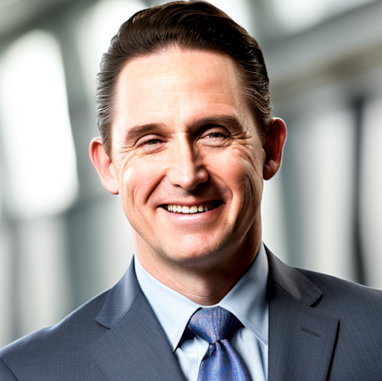
ERIC G. SPANN, M.D., M.B.A
Mountain View, Arkansas
espann@syngent.org
(870) 214-9660 (cell)

Award winning physician leader in active clinical practice of family practice and wound care. Family medicine experience includes obstetrics, emergency medicine, hospitalist and ICU. Administrative experience at small rural facilities, a large hospital, and a health system. Administrative roles include Medical Director, Physician Advisory Board Member to CEO, Chairman of Hospital Board of Directors, and Board of Directors of both a health system and health plan. Focus in healthy weight loss/longevity/hormone therapy. Examined over 175 cases of child abuse and cared for/supervised care of hundreds of wound patients. Experienced expert witness.

EXPERIENCE

Baxter Regional Hometown Clinics - Mountain View, Mountain View, Arkansas
Clinician 2016-Present
Full-time family practice clinic services treating children and adults, comprehensively. Supervised seven nurse practitioners (two certified NP wound specialists) and one physician’s assistant full-time.

Medical Director 2017-2021
Medical Directorship responsibilities for six physicians and twelve nurse practitioners. Issues dealt with include clinical and professional performance, standard of care, accountable care, productivity, value-based programs, scheduling and attendance, financial performance and compensation.

Member of Physician Advisory Counsel to the CEO 2022-Present
System representative for rural physicians.

Coral Seas Medical Missions, Mountain View, Arkansas 2000-Present
Chief Medical Officer
Medical Director and CMO for all medical operations of the King Foundation, Inc., 501(c)3 through charitable medical teams to the island nation of Vanuatu. We operate a small mobile clinic annually to serve the medical and surgical needs of this developing nation.

Syngent, Mountain View, Arkansas
Expert Witness 2017-Present
Serve as an expert witness in cases including: wound care cases, child abuse, standard of care for comprehensive outpatient family medicine, supervision of midlevel provider quality of care, hormone/anti-aging/vitality/weight loss treatment.

Mountain View Family Practice, Mountain View, Arkansas and Metropolitan Kansas City 2011-2015
Family Practice Clinican
Half-time primary care practice while continuing concierge and emergency practice across North Arkansas.
Stone County Medical Center, Mountain View, Arkansas/Batesville, Arkansas 2011-2018
Emergency Department Physician
Emergency medicine physician at White River Health System, Batesville and Mountain View.

Mercy Hospital, Berryville, Berryville, Arkansas 2007-2011
Hospitalist Director
Piloted and ran hospitalist service for 25 bed hospital from inception in 2007 to conversion to full-time staffing in 2011. Coordinated services for five physician cohort responsible for this service.

Mercy Health, Green Forest, AR 1994-2011
Clinical Physician
Full-time family practice with obstetrics, hospital practice with ICU privileges for 18 years.

Carroll City Child Abuse Task Force, Green Forest, Arkansas 1994-2001
Medical Director
Forensic examiner for child abuse for north-Central Arkansas, examining and investigating 175 cases/allegations over 7 years. Significant testifying experience.

Associate Professor Family Medicine, Fayetteville, Arkansas 1995-1999
Clinical Training Staff
Served as teaching assistant professor for family medicine residents in clinic, minor surgery, child abuse evaluations, procedural skills, wellness.

BOARD CERTIFICATIONS

American Board of Family Physicians 1994, 2004, 2018
Certification Number: 1083777080

American Board of Wound Management 2024
Certificate Number: CWSP017329

EDUCATION

University of Arkansas Sam M. Walton College of Business, Fayetteville, AR 2023
Master of Business Administration, Healthcare Track.

Louisiana State University Medical Center, Shreveport, LA 1994
Family Practice Residency
Chief Resident, 1994

Louisiana State University Medical Center, Shreveport, LA 1991
Doctor of Medicine

Louisiana College, Pineville, LA 1987
Bachelor of Science

LICENSES

Arkansas State Medical Board 1994-present
Active/Unlimited: E-0234
ADMINISTRATIVE EXPERIENCE SERVICE

Position, Executive MBA Advisory Board, Sam M. Walton College of Business 2022-present
Member, Physician Advisory Council to CEO, Baxter Health System 2022-present
Position, Clinical Practice Committee, American College of Sports Medicine 2021-2023
Medical Director, Baxter Regional Hometown Clinics 2017-2022
Board of Directors, Mercy Health System, Springfield, MO 2009-2011
Board of Directors, Mercy Health Plans, St. Louis, MO 2007-2008
Chairman of Board, Mercy Hospital, Berryville, AR 2005-2011

ADDITIONAL CERTIFICATIONS

Certified Ironman Triathlon Coach – World Triathlon Corporation 2016-2022
Fellow of American Academy of Family Physicians 2001
Executive Leadership Presence – Wharton School of Business 2023
Blockchain Council Certifications
Certified Generative AI Expert – Certificate ID: 9466120 2024
Certified Artificial Intelligence Expert – Certificate ID: 91417142 2024
Certified ChatGPT Expert – Certificate ID: 90539026 2023

PROFESSIONAL SOCIETIES

American College of Healthcare Executives 2022-present
American Academy of Family Practice, Fellow 2001-present

AWARDS

University of Arkansas, Sam M. Walton College of Business 2023
Outstanding Executive MBA Student

Mercy Hospital, Berryville 2010
Physician Excellence Award

Mercy Health System, Mercy Clinic 2009
Community Service Award; Physician Health and Fitness Champion

LSUMC-S 1994
Family Medicine Resident, Spirit of Family Practice Award

STAFF PRIVILEGES

Baxter Health System, Mountain Home, AR 2016-present
Active Outpatient Staff

