The Property Management Standard of Care – What is it and why is it important?
Hint: It’s Ordinary Care
By: Jeffrey S. Lapin, CPM®, ARM®, DREI®
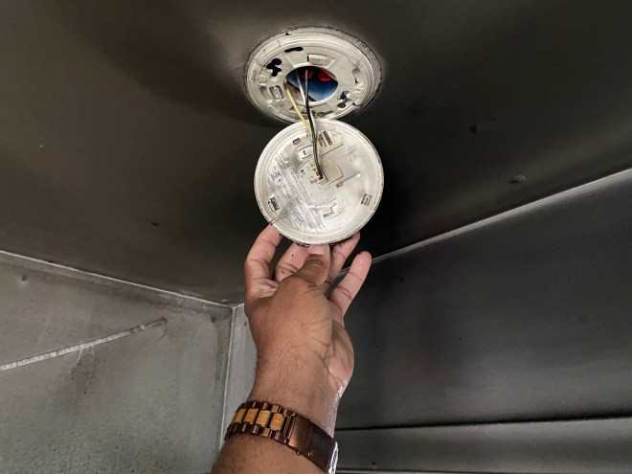
Introduction:
The property management standard of care with regard to commercial or residential rental properties is the measure by which a property owner or property manager’s actions or lack thereof will be judged when determining if an injured party is entitled to recover when claiming negligence by that property owner/manager.
Our commercial and multi-family residential properties are usually open to the public to reside, conduct business and visit. In other words, if we actively invite the public, including our tenants and residents to enter upon these properties and charge rent to do so, we are going to held to a standard of care. In such cases, we have a duty of reasonable, ordinary or due care to provide a reasonably safe environment for the public while at these properties. This includes invitees such as tenants, residents, guests and visiting contractors or prospective renters. This is known as the standard of care for property management.
When someone is injured at one of our properties, the property owner’s and property manager’s actions and efforts to keep the property reasonably safe will likely be scrutinized. Similarly, the property owner and manager should make it a priority to determine the likely cause of the injury and begin an internal investigation to re-examine inspection and maintenance procedures. The purpose of such an investigation is to verify that the proper procedures were in place and if so, that they were properly followed. The goal is also to prevent future injuries.
As an expert witness in property management cases, I am often asked to review the policies, procedures and actions by property owners and managers and to issue opinions as to whether the injuries to members of the public were the result of the failure by the owner or manager to follow the property management standard of care pertaining to such a property.
My 40-year career as a property manager, property owner, property management supervisor and property management company co-owner, as well as my many years of designing and delivering professional property management education and training, provides me with a wealth of knowledge and experience to issue such opinions (CV of Jeffrey Lapin, CPM).
Far too often, my review of the discovery materials in these cases results in finding that either the property owner and/or the manager had improper or insufficient policies and procedures designed to find and reasonably correct unsafe conditions; or, that mostly adequate policies and procedures existed but that they were not followed. In other words, often the property owner and manager failed to meet the standard of care for their properties, resulting in injuries to tenants, visitors or other invitees to the property.
The purpose of this article is to help property owners and managers to recognize their responsibility to ensure reasonably safe properties and to understand what courts of law often find to be negligence by these parties in meeting the property management standard of care.
What is the Property Management Standard of Care?
The standard of care for owners and managers of properties open to the public is not perfection. Nor does it require that a property has absolutely no injuries. That standard would not be deemed “reasonable”. Courts generally recognize that commercial and residential properties are busy, active places at which hazards can and do get created frequently and often instantaneously.
Courts usually rule however, that property owners and property managers have an affirmative duty to reasonably discover foreseeable hazards, take actions to mitigate or minimize the chances of someone getting injured and then eliminate those hazards in a reasonable period of time so as to restore the property to a reasonably safe condition.
Those who own or manage such properties should understand how their polices, procedures and actions might be judged if someone is injured and, that they must often justify how they inspected and maintained the property.
What is Considered Negligence?
Negligence is defined by a popular law dictionary (www.dictionary.law.com) as a “failure to exercise the care toward others which a reasonable or prudent person would do in the circumstances, or taking action which a reasonable person would not.”
The Reasonable Person standard is very important for us to understand. A determination of whether the Defendant was careful enough is usually based on what a reasonable person would do (or not do) in the same circumstances. Once again, perfection is not the measure by which we are judged, but rather what is reasonable in the circumstances.
In other words, the test is an objective one, not a subjective one. It is not about whether the Defendant did the right thing, but whether a reasonable person in the same circumstances would do or not do what the Defendant did or failed to do. What this means is that our actions will likely be compared to the reasonable person. But what do courts expect the reasonable person to do (in this case, the reasonable Property Manager)?
First, the reasonable property manager or owner takes careful and prudent precautions against foreseeable risks, but is usually not required to do so for every conceivable danger. He or she considers the likelihood of harm and the potential severity of such harm and acts accordingly. This concept of foreseeability simply means that if a reasonably qualified and trained property manager, exercising ordinary care, would likely discover a hazardous condition on property and would consider that hazard to be likely to injure someone, then that person would take reasonable precautions to make it safe temporarily and then proceed to fix it in a permanent fashion.
And because this test is an objective one, meaning that it is not based on someone’s personal perspectives or preferences, but rather upon an unbiased observation or decision, it does not matter that the Defendant in the case did “their best”. What matters is whether what was done would be what a reasonable person in the same circumstances would likely do.
A Higher Standard for Professionals
In the case of a property manager, the standard of care for property management professionals is different than it would be for someone who is not a trained and experienced property professional. In other words, we property owners and managers are held to a higher standard. The standard of care for property management is “What would a reasonably competent, trained and experienced professional do in similar circumstances?”
We are expected to be “reasonably competent” and “reasonably trained” professionals. Those of us who are acting as the manager of a commercial or residential property that is used as a rental property, are rightfully expected to do a better job of discovering and resolving unreasonably dangerous conditions than that which would be done by someone who is not a professional property manager at their single family residence.
The terms reasonably competent and reasonably experienced means that if we hold ourselves out to be professional property managers, then the court will likely hold us to a higher standard of care than someone who does not hold themselves out as a property professional. And there is usually no allowance for the property manager that has insufficient experience for the job. The court will usually not go easier on an owner that self-manages without the requisite skills or who hires an incompetent or inexperienced manager or fails to adequately supervise property managers.
Error in Judgement vs. Negligence
Errors in judgement, meaning that in hindsight, the wrong decision was made by the property owner or manager resulting in injury to the plaintiff, can and often do result in a finding of no negligence.
For example, what if the attorney for the defendant can establish that the property owner or property manager made the same decision as a reasonable professional (acting carefully and with the requisite knowledge and experience) might have made in similar circumstances with the same information? Is it possible or likely in such a circumstance that the property manager or owner defendant would escape liability for the injury?
The short answer is that yes, according to attorneys that have retained me on such cases and whom were consulted for this article, such an error in judgement wherein a reasonably qualified, competent and experienced property management professional acting on the best information that he or she had at the time, made a decision that in the end, turned out to be wrong, would likely not be adjudicated as negligence.
Remember that negligence is a legal finding. And every case is different, just as every judge and jury is unique. We as property professionals must make the very best, well-informed decisions that we can in each circumstance.
Compliance with Statutory Standards
Often the actions of a property owner or manager are mandated by codes or other legal standards. If it can be established that the owner or manager was complying with applicable law and that an injury occurred as a result of a condition that was required by law or that the law prevented the owner or manager from correcting a certain condition on the property, it is more likely that negligence will not be found. In other words, we should not be penalized for following the law.
Following the law or being compliant with applicable codes however, would be a poor defense if the law resulted in a demonstrably unsafe condition and the property owner and/or manager failed to recognize that it was necessary to go above and beyond minimal code requirements (legally of course). Once again, the property management standard of care is reasonably safe, not perfectly safe.
The Importance of Education and Training
All too often, I find that the property manager, although well intentioned, was simply not properly skilled and experienced enough to establish the minimum level of action necessary to properly avoid an injury on the property. Just as new drivers are statistically more likely to get into traffic collisions, new property managers are more likely to fail to discover and correct unreasonably dangerous conditions.
As a long time designer and instructor of professional real estate education courses for IREM® (www.irem.org/education) and others, I know the vital importance of proper training and education. Property owners who self-manage and management supervisors for third-party managers, should require all property management employees to attend and participate in professional development courses and document that training. That is just good practice and demonstrates a reasonable effort to be pro-active about property hazards.
I often find that the most egregious failures to meet the property management standard of care, and which frequently result in preventable injuries to the public, come from owners and property management companies that do not require such training and education. We must invest in those in whom we place such an awesome responsibility to keep the public reasonably safe.
Conclusion:
As an expert witness in the property management standard of care for all kinds of properties, having been retained on over 85 separate cases, I base a portion of my opinions on what we teach at IREM® in courses such as MNT402 (Managing Maintenance Operations and Property Risk) which teaches property managers and property owners how to meet the property management standard of care. As an IREM® instructor for that course as well as others, I know that most property owners and managers who join IREM® and get the excellent education and training that IREM® offers, take safety seriously and usually employ the policies, standards, practices and procedures that we teach.
It is also true however, that too many people are still getting injured on our properties from causes that were both foreseeable and preventable. And while unforeseen accidents and injuries do happen, as an industry, we need to do a better job of inspection, maintenance and repair.
The key point is that property managers must obtain professional experience and competence through proper training, education and mentorship before assuming the responsibility of managing properties and must continue to grow and learn better and more effective techniques to establish and maintain reasonably safe environments at their properties.
Hopefully, the concepts that I have laid out in this article will help our industry improve how we serve and protect the public at our properties.
DISCLAIMER:
I AM NOT AN ATTORNEY. I DO NOT AND AM NOT PROVIDING LEGAL ADVICE OR COMING TO LEGAL CONCLUSIONS. THE OPINIONS I HAVE EXPRESSED HEREIN ARE MINE AND MINE ALONE AND ARE BASED UPON MY KNOWLEDGE AND EXPERIENCE AS A REAL ESTATE PROFESSIONAL AND AS AN EXPERT WITNESS. IF YOU NEED LEGAL ADVICE, PLEASE RETAIN THE SERVICES OF A QUALIFIED AND LICENSED ATTORNEY AT LAW.
Jeffrey S. Lapin, CPM, ARM, DREI is a 40-year veteran of the property management industry, having managed all types of properties throughout the United States. He has dedicated the later portion of his professional career to helping others in the property management industry to become more proficient and to improve the properties that they manage.

